Senior Design I EML 4551C

Team 520: Simulated Assembly Line and Processing Workstation

Concept Selection

FAMU-FSU College of Engineering
2525 Pottsdamer St, Tallahassee, FL 32310

Team Members:
David DiMaggio: dcd14@my.fsu.edu
Cheyenne Laurel: crl15d@my.fsu.edu
Boluwatife Olabiran: boluwatife1.olabiran@famu.edu
Nataajah Taylor: nataajah1.taylor@famu.edu
Joell Williams: joell1.williams@famu.edu

Faculty Advisor:
Dr. Dorr Campbell

Sponsor:
Tallahassee Community College

Instructor:
Dr. Shayne McConomy

House of Quality
Using the needs provided by our sponsor along with the engineering characteristics that needed to be taken into consideration in order to achieve the requirements, a house of quality was used to determine which characteristics would be the most important when moving forward. It was determined that the PLC Programming component would be the most important since its function is required in each process in the machine, with a relative weight of 41.95% of the engineering characteristics. The component in second was the accuracy of the property sorting, which is a general term for the proper sorting of the object based off the material and size determination, and had a relative weight of 21.40%. The accuracy of the material and size detection had the same relative weight of 13.98% since both engineering characteristics provide independent functions but both must work in order for the machine to complete all requires processes. While the average cycle time is a factor to be considered and must fall within a certain range in order for the functions to be feasible, there is no time requirement for the cycle time, so the relative weight of the average cycle time is 6.99%. The least important characteristics that will be taken into account is the object width with a relative weight of 1.06%, and the conveyor belt width with the lowest relative weight of 0.42% since the group is restricted to the conveyor belt purchased by the sponsor.

 |  | Engineering Characteristics
Improvement Direction: |  | ↑ | ↑ | ↑ | ↓ | ↑ |  | ↑
Units: |  | inches | percentage | percentage | seconds | inches | N/A | percentage
Customer Requirements | Importance Factor | Object Width | Accuracy of Material Detection | Accuracy of Size Detection | Average Cycle Time | Conveyor Width | PLC Programming | Accuracy of Property Sorting
Detects Material | 5 |  | 9 |  |  |  | 9 | 9
Detects Size | 5 | 1 |  | 9 |  |  | 9 | 9
Modular | 5 |  |  |  |  |  | 9
Quick Sorting | 2 |  | 3 | 3 | 9 | 1 | 9 | 3
Move Material | 5 |  | 3 | 3 | 3 |  | 9 | 1
 | Raw Score: | 5 | 66 | 66 | 33 | 2 | 198 | 101
 | Relative Weight: | 1.06% | 13.98% | 13.98% | 6.99% | 0.42% | 41.95% | 21.40%
 | Rank Order: | 6 | 3 | 3 | 5 | 7 | 1 | 2

Figure 1: Simulated Assembly Line House of Quality

Pugh Chart
The group created eight different conceptual designs that were actually drawn based off the ideas generated during Concept Generation. A drawing of each of the different concepts is attached in the appendix. Using the engineering characteristics where each one has a weight from 1-5, with one being not important and five being most important, each of the characteristics were compared against each of the concepts to decide if that process would be improved or hindered when compared to a datum design. The weights make sure the most important characteristics get taken into account the most when selecting a concept to proceed with. Through this method, it was determine that the top three concepts were Concept 1, 3, and 4 since they have the largest differences in the sums of the weighted positives and negatives. Concept 3 is currently the first choice with a score of 16 while Concept 1 is in second with a score of 14, and Concept 4 in third with a score of 3. These three concepts will be further evaluated through AHP to check for any inconsistencies or bias when rating and choosing between the three concepts.

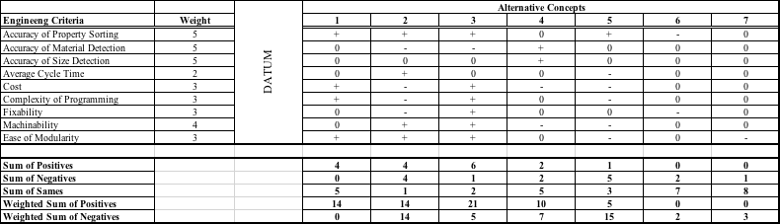
Figure 2: Pugh Chart

Normalized Criteria Comparison Matrix
Using the engineering characteristics that were determined to be the most important from the House of Quality, the level of importance was further verified using the Analytical Hierarchy Process (AHP), which is a mathematical way of checking for inconsistencies or biases in the ratings of the Pugh Chart and House of Quality. Although their functions are very similar, AHP uses mathematical verification to try and eliminate human misjudgment. The normalized criteria comparison matrix below was created by going through each column and row to compare the importance of each characteristic against the others. By normalizing each column, each engineering characteristic can be judged by the resultant criteria weights to check the level of consistency in concept selection.

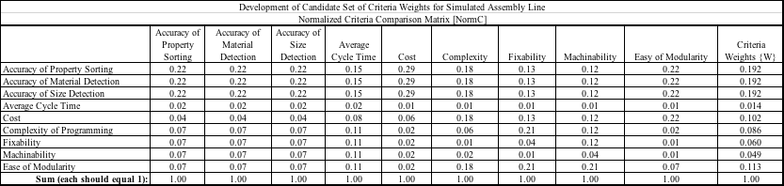
Figure 3: Normalized Criteria Comparison Consistency Matrix

Consistency Check

The consistency check consists of the values of the weighted sum vector, criteria weights, and the consistency vector. The average consistency was 10.60, Consistency index is 0.1995, and the consistency ratio is 0.138. The CR was .0038 larger than .10 showing the design matrix was reliable with the purpose for the project.

 | Weighted Sum Vector | Criteria Weights | Consistency Vector
Accuracy of Property Sorting | 0.192 | 2.13939 | 11.15
Accuracy of Material Detection | 0.192 | 2.13939 | 11.15
Accuracy of Size Detection | 0.192 | 2.13939 | 11.15
Average Cycle Time | 0.014 | 0.14282 | 9.85
Cost | 0.102 | 1.21369 | 11.92
Complexity of Programming | 0.086 | 0.89833 | 10.50
Fixability | 0.060 | 0.57369 | 9.52
Machinability | 0.049 | 0.44735 | 9.17
Ease of Modularity | 0.113 | 1.24272 | 10.95

Figure 4: Consistency Vector Values
Final Rating Matrix
Selection Criteria | Accuracy of Property Sorting | Accuracy of Material Detection | Accuracy of Size Detection | Average Cycle Time | Cost | Complexity of Programming | Fixability | Machinability | Ease of Modularity
Concept 1 | 0.30 | 0.19 | 0.28 | 0.19 | 0.08 | 0.10 | 0.25 | 0.25 | 0.33
Concept 3 | 0.37 | 0.08 | 0.64 | 0.75 | 0.72 | 0.69 | 0.66 | 0.66 | 0.33
Concept 4 | 0.33 | 0.72 | 0.07 | 0.75 | 0.19 | 0.21 | 0.09 | 0.09 | 0.33
Figure 5: Final Rating Matrix

Final Concept Selection Decision
After normalizing the matrix and gaining the weights of the different concepts, number 3 was shown to be the best design concept. The final matrix reflected the Pugh Chart as it had the most positives of all the designs. In design concept 3 the accuracy of material detection was the worst case and the ease of modularity was consistent between the three designs; however, the third design made up for the rest of the categories of the design matrix.
Concept # | Value
1 | 0.23
3 | 0.46
4 | 0.31
Figure 6: Final Selection Values

Appendix

Concepts #datum-3
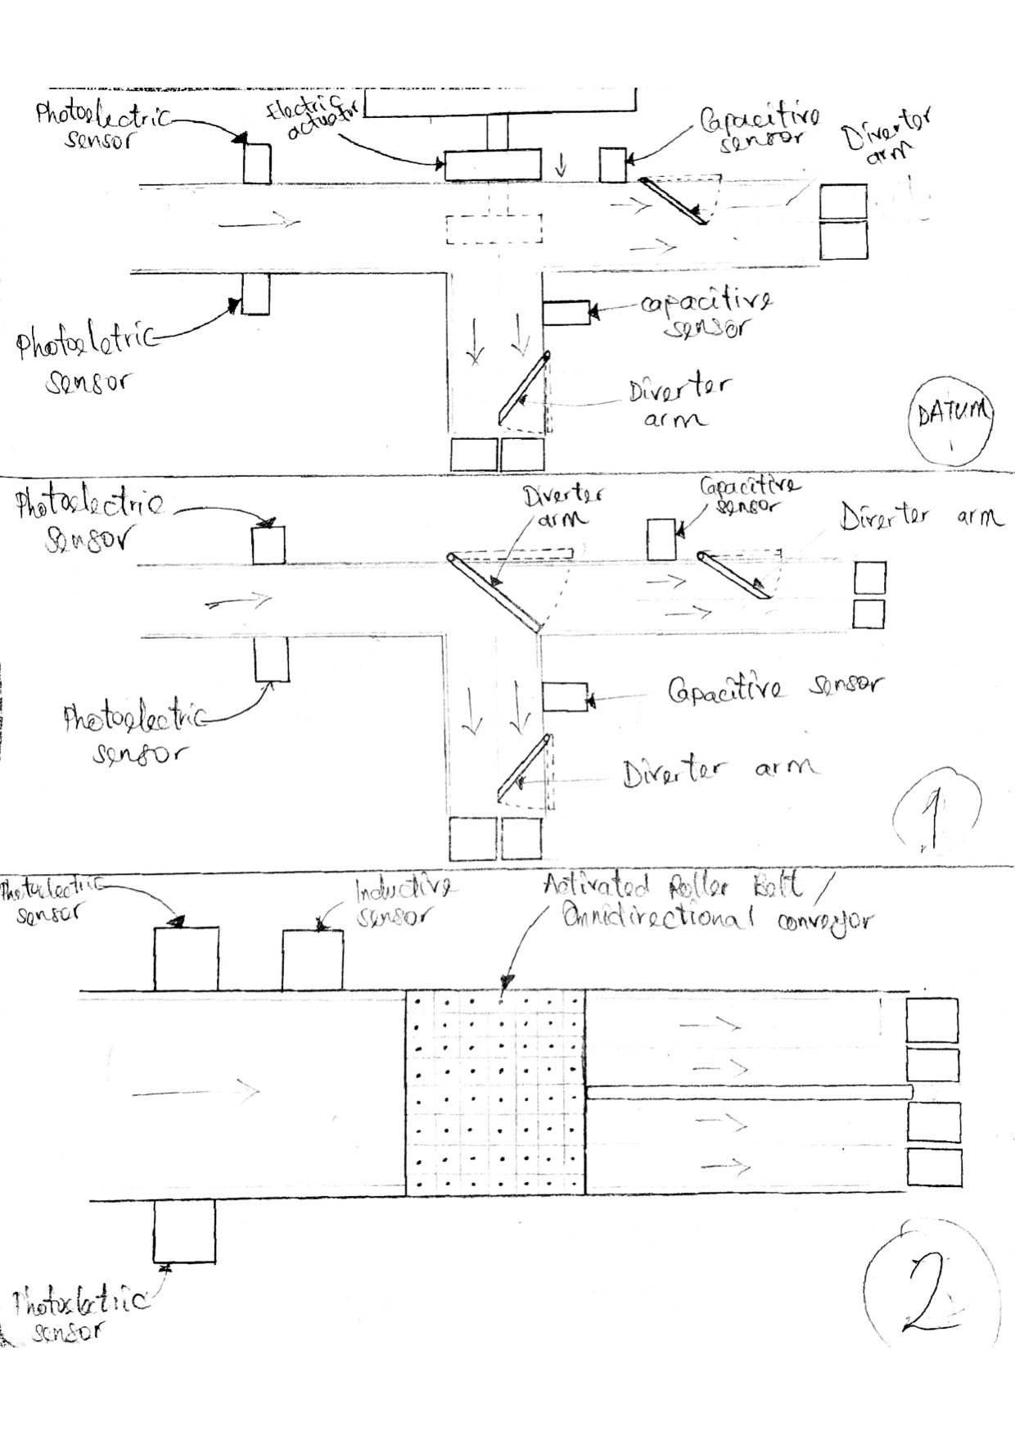

Concept #4
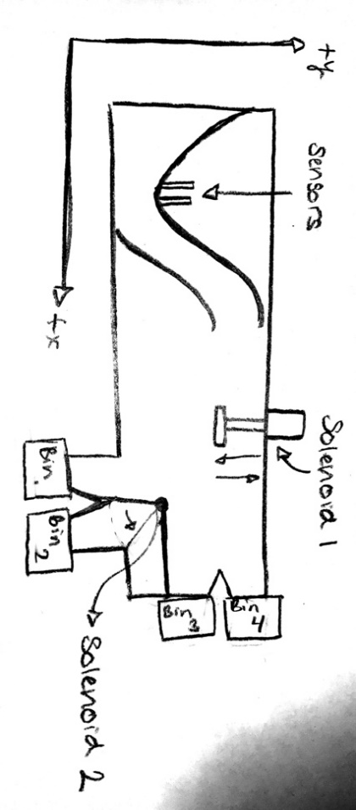
Concept #5
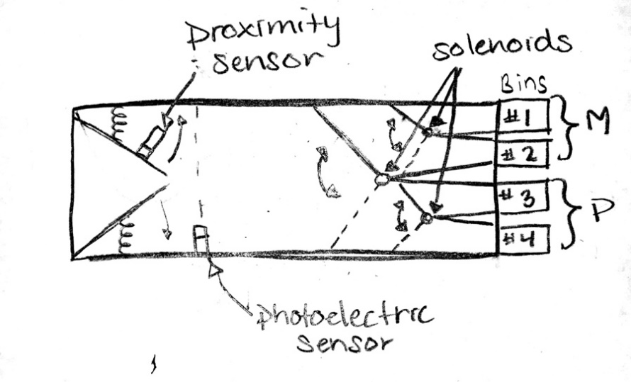

Concept #6

Concept #7
